Syeda Reeha Quasar

14114802719

4C7

Aim

Create a class called LIST with two pure virtual function store () and retrieve (). To store a value call store and to retrieve call retrieve function. Derive two classes stack and queue from it and override store and retrieve.

Experiment - 19

Object Oriented Programming Lab

# **EXPERIMENT – 19**

## **Aim:**

Create a class called LIST with two pure virtual function store () and retrieve (). To store a value call store and to retrieve call retrieve function. Derive two classes stack and queue from it and override store and retrieve.

## **Source Code:**

#include <iostream>

#include <conio.h>

using namespace std;

class LIST

{

public:

    virtual void store() = 0;

    virtual void retrieve() = 0;

};

class B : public LIST

{

public:

    void store()

    {

        cout << "function called" << endl;

    }

    void retrieve()

    {

        cout << "fuction calling" << endl;

    }

};

int main()

{

    B obj;

    obj.store();

    obj.retrieve();

    getch();

}

## **Output:**

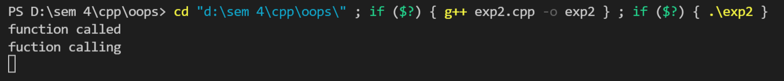

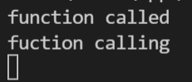

# **Viva Questions**

#### Q1) What is a virtual function?

Ans.

A virtual function is a member function in the base class that we expect to redefine in derived classes.

Basically, a virtual function is used in the base class in order to ensure that the function is overridden. This especially applies to cases where a pointer of base class points to an object of a derived class.

*Q2) What is child class?*

*Ans.*

*A class that inherits another class is known as child class, it is also known as derived class or subclass.*

*Q3) What is parent class?*

*Ans.*

*The class that is being inherited by other class is known as parent class, super class or base class.*

### Q4) What are the advantages of using inheritance in C++ Programming?

Ans.

The main advantages of inheritance are code reusability and readability. When child class inherits the properties and functionality of parent class, we need not to write the same code again in child class. This makes it easier to reuse the code, makes us write the less code and the code becomes much more readable.

Q5) What are advantages and disadvantages of inheritance?

Ans.

Disadvantages: -

* Inherited functions work slower than normal function as there is indirection.
* Improper use of inheritance may lead to wrong solutions.
* Often, data members in the base class are left unused which may lead to memory wastage.
* Inheritance increases the coupling between base class and derived class. A change in base class will affect all the child classes.

Advantages:

* Inheritance promotes reusability. When a class inherits or derives another class, it can access all the functionality of inherited class.
* Reusability enhanced reliability. The base class code will be already tested and debugged.
* As the existing code is reused, it leads to less development and maintenance costs.
* Inheritance makes the sub classes follow a standard interface.
* Inheritance helps to reduce code redundancy and supports code extensibility.
* Inheritance facilitates creation of class libraries.